|  |
| --- |
| **KATALOG PROIZVODA** |
| MOB:099/841-6236 |
|  |
| PRAECONIUS D.O.O. ,Anina 91 A ,ZAGREB |
| www.praeconius.eu |
|  |
|  |
|  |

|  |  |  |
| --- | --- | --- |
| **NAZIV PROIZVODA(čaša Casablanca)** | **EUR** | |
| SET ČAŠA CLASSICO 22 **12/1** |  | 8,90 |
| SET ČAŠA CLASSICO 31 VODA **12/1** |  | 8,90 |
| SET ČAŠA CLASSICO 31 **0,2 ŽIG** **12/1** |  | 9,29 |
| SET ČAŠA CLASSICO 29 NISKO DNO **12/1** |  | 6,76 |
| SET ČAŠA CLASSCIO 29 ND 0,2 ŽIG **12/1** |  | 7,69 |
| SET ČAŠA CLASSICO 32 LD **12/1** |  | 8,36 |
| SET ČAŠA CLASSICO 25 WHISKY **12/1** |  | 8,36 |
| SET ČAŠA CLASSICO 20 WHISKY **12/1** |  | 7,56 |
| SET ČAŠA CLASSICO 16,5cl **12/1** |  | 8,29 |
| SET ČAŠA CLASSICO 14cl **12/1** |  | 7,83 |

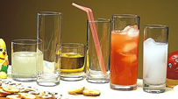

|  |  |  |
| --- | --- | --- |
| **NAZIV PROIZVODA(čaša Marocco)** | **EUR** | |
| GRT. ČAŠA MAROCCO SHOT 3cl **6/1** |  | 2,78 |
| SET ČAŠA MAROCCO 14 CL **12/1** |  | 6,17 |
| SET ČAŠA MAROCCO WHISKY 23 cl **12/1** |  | 7,10 |
| SET ČAŠA MAROCCO VODA 28 cl **12/1** |  | 7,69 |
| SET ČAŠA MAROCCO VODA 35 cl **12/1** |  | 9,29 |
| SET ČAŠA MAROCCO VODA 42 XL **12/1** |  | 11,94 |

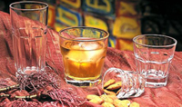

|  |  |  |
| --- | --- | --- |
| SET ČAŠA GEMIŠT/BAČVICA 0,2 ŽIG **24/1** |  | 12,34 |

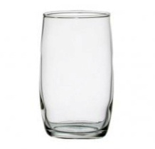

|  |  |  |
| --- | --- | --- |
| SET ČAŠA ZA PIVO MYKONOS **6/1** |  | 6,63 |
| ***kolor kutija,*** 31 cl (8 seta u kutiji) |  |  |
| SET ČAŠA ZA PIVO MYKONOS **12/1** |  | 9,55 |
| SET ČAŠA ZA PIVO MYKONOS PIVO **0,2 ŽIG** **12/1** |  | 10,35 |

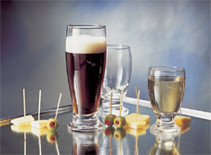

|  |  |  |
| --- | --- | --- |
| ČAŠA CHEERIO LIKER 4 CL **96/1** |  | 0,29 |
| ČAŠA CHEERIO LIKER **0,03 žig** **96/1** |  | 0,39 |

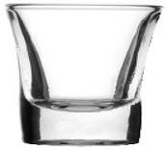

|  |  |  |
| --- | --- | --- |
| PEPELJARA 10,5 cm PROZIRNA **24/1** |  | 0,71 |
| PEPELJARA 14 cm PROZIRNA **24/1** |  | 1,79 |
| PEPELJARA 10,5 cm CRNA **24/1** |  | 1,12 |

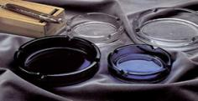

|  |  |  |
| --- | --- | --- |
| SET ČAŠA GLORY WHISKY 29 cl 6/1 |  | 4,87 |
| ***kolor kutija*** ( 8 seta u kartonu ) |  |  |
| SET ČAŠA GLORY SOK 36 cl 6/1 |  | 4,87 |
| ***kolor kutija*** ( 6 seta u kartonu ) |  |  |



C:\Users\marij\OneDrive\Radna površina\ŽLIČICA BIJELA KAVA.jpg 

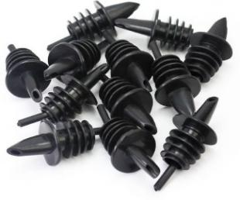

Žličica espresso 1/1 0,48

Žličica bijela 1/1 0,54

Žličica nescaffe,kakao 1/1 0,56

Krpa za poliranje čaša (damast) 1,72

Istakaći (pureri ) plastični 1/1 0,30

|  |  |  |
| --- | --- | --- |
| SET ČAŠA KOUROS B.V. 16,5 cl **12/1** |  | 7,96 |
| SET ČAŠA KOUROS VODA 26 cl **12/1** |  | 9,02 |
| SET ČAŠA KOUROS B.V. **0,1 ŽIG**. **12/1** |  | 8,69 |
| SET ČAŠA KOUROS B.V. 0,2 ŽIG 12/1 |  | 10,1 |

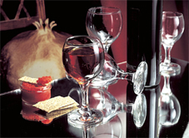

|  |  |  |
| --- | --- | --- |
| **Kouros - 94502** | **Kouros - 93502** | **Kouros - 91502** |
| **bijelo vino** | **crno vino** | **voda** |
| **165 ml** | **210 ml** | **260 ml** |
| **h = 133 mm** | **h = 147 mm** | **h = 160 mm** |
| **fi max 70 mm** | **fi max 76 mm** | **fi max 82 mm** |

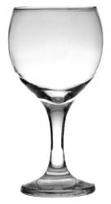 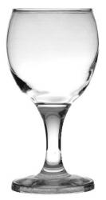 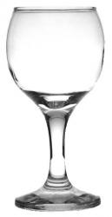

|  |  |  |
| --- | --- | --- |
| Čaša Marocco 35cl,šest boja **48/1(plava,žuta,zelena,crvena,ljubičasta,narančasta)** |  | 1,26 |

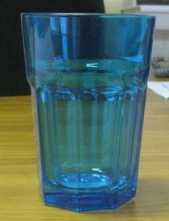 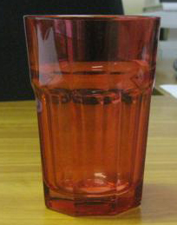 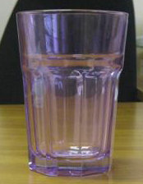

|  |  |  |  |  |  |  |
| --- | --- | --- | --- | --- | --- | --- |
|  |  |  |  |  |  |  |
|  |  |  |  |  |  |  |
|  |  |  |  |  |  |  |
| |  | | --- | |  | |  |  |  |  | **EUR** |  |
|  |  |  |  |  |  |  |
|  |  |  |  |  |  |  |
|  |  | SET ČAŠA SLADOLED CHICAGO 6/1 7,83 | | | |  |
|  |  |  |  |  |  |  |
|  |  |  |  |  |  |  |
|  |  |  |  |  |  |  |
|  |  |  |  |  |  |  |
|  |  |  |  |  |  |  |
|  |  |  |  |  |  |  |
|  |  |  |  |  |  |  |
|  |  |  | | | |  |
| |  | | --- | |  | |  | SET ČAŠA SLADOLED FLAMENGO 6/1 7,10 | | | |  |
|  |  |  |  |  |  |  |
|  |  |  |  |  |  |  |
|  |  |  |  |  |  |  |
|  |  |  |  |  |  |  |
|  |  |  |  |  |  |  |
|  |  |  |  |  |  |  |
|  |  |  |  |  |  |  |
|  |  |  |  |  |  |  |
| |  | | --- | |  | |  | STAKLENA ZDJELICA 9 cm 0,46 | | | |  |
|  |  |  | | | |  |
|  |  |  | | | |  |
|  |  |  | | | |  |
|  |  |  | | | |  |
|  |  |  |  |  |  |  |
|  |  |  |  |  |  |  |
|  |  |  |  |  |  |  |
|  |  |  |  |  |  |  |
|  |  |  |  |  |  |  |
| |  | | --- | |  | |  |  |  |  |  |  |
|  |  | Set čaša Alexander VODA 32,5 cl SUPERIOR,viši stalak 6/1 | | | | 6,63 |
|  |  |  |  |  |  |  |
|  |  |  |  |  |  |  |
|  |  |  |  |  |  |  |
|  |  |  |  |  |  |  |
|  |  |  |  |  |  |  |
|  |  |  |  |  |  |  |
|  |  |  |  |  |  |  |
|  |  |  |  |  |  |  |
|  |  |  |  |  |  |  |
|  |  |  |  |  |  |  |
|  |  | VRČ BISTROT 0,25 LIT 12/1 0,99 | | | |  |
| |  | | --- | |  | |  | VRČ BISTROT 0,5 LIT 12/1 1,50 | | | |  |
|  |  |  | | | |  |
|  |  |  |  |  |  |  |
|  |  |  |  |  |  |  |
|  |  |  |  |  |  |  |
|  |  |  |  |  |  |  |
|  |  |  |  |  |  |  |
|  |  |  |  |  |  |  |

|  |  |  |  |  |  |  |  |  |  |  |  |  |  |
| --- | --- | --- | --- | --- | --- | --- | --- | --- | --- | --- | --- | --- | --- |
|  |  | | | | | | | | | | | | |
|  |  | | |  | |  | |  | |  |  | | |
|  |  | | |  | |  | |  | |  |  | | |
| |  | | --- | |  | |  | | |  | | | | | | |  | | |
|  |  | | |  | |  | |  | |  | EUR | | |
|  |  | | |  | |  | |  | |  |  | | |
|  |  | | | Set čaša šampanj 170 cl DUCALE 6/1 | | | | | | |  | | |
|  |  | | | kolor kutija (6 seta u kartonu) | | | | | | | 5,30 | | |
|  |  | | |  | |  | |  | |  |  | | |
|  |  | | |  | |  | |  | |  |  | | |
|  |  | | |  | |  | |  | |  |  | | |
|  |  | | |  | |  | |  | |  |  | | |
|  |  | | |  | |  | |  | |  |  | | |
|  |  | | |  | |  | |  | |  |  | | |
|  |  | | | Set čaša bijelo vino 210 cl DUCALE 21 6/1 | | | | | | |  | | |
|  |  | | | kolor kutija (6 seta u kartonu) | | | | | | | 5,77 | | |
|  |  | | |  | |  | |  | |  |  | | |
|  |  | | |  | |  | |  | |  |  | | |
|  |  | | |  | |  | |  | |  |  | | |
|  |  | | |  | |  | |  | |  |  | | |
|  |  | | |  | |  | |  | |  |  | | |
|  |  | | |  | |  | |  | |  |  | | |
|  |  | | |  | |  | |  | |  |  | | |
|  |  | | |  | |  | |  | |  |  | | |
|  |  | | | Set čaša crno vino 270 cl DUCALE 27 6/1 | | | | | | |  | | |
|  |  | | | kolor kutija (6 seta u kartonu) | | | | | | | 7,23 | | |
|  |  | | |  | |  | |  | |  |  | | |
|  |  | | |  | |  | |  | |  |  | | |
|  |  | | |  | |  | |  | |  |  | | |
|  |  | | |  | |  | |  | |  |  | | |
|  |  | | |  | |  | |  | |  |  | | |
| |  | | --- | |  | |  | | |  | |  | |  | |  |  | | |
|  |  | | |  | |  | |  | |  |  | | |
|  |  | | |  | |  | |  | |  |  | | |
|  |  | | |  | |  | |  | |  |  | | |
|  |  | | | Set čaša voda 310 cl DUCALE 31 6/1 | | | | | | |  | | |
|  |  | | | kolor kutija (4 seta u kartonu) | | | | | | | 7,49 | | |
|  |  | | |  | |  | |  | |  |  | | |
|  |  | | |  | |  | |  | |  |  | | |
|  |  | | |  | |  | |  | |  |  | | |
|  |  | | |  | |  | |  | |  |  | | |
|  |  | | |  | |  | |  | |  |  | | |
|  | |  |  | |  | |  | |  | | |  |
|  | |  |  | |  | |  | |  | | |
|  | |  | | | | | | | | |
|  | |  | |  | |  | |  | | |
|  | |  |  | |  | |  | |  | | | |
|  | |  |  | |  | |  | |  | | |  |
|  | |  |  | |  | |  | |  | | |  |
|  | |  |  | |  | |  | |  | | |  |
|  | |  |  | |  | |  | |  | | |  |
|  | |  |  | |  | |  | |  | | |  |
|  | |  |  | |  | |  | |  | | |  |
|  | |  |  | |  | |  | |  | | |  |
|  | |  |  | |  | |  | |  | | |
|  | |
|  | |  |  | |  | |  | |  | | |  |
|  | |  |  | | | | | | | | |  |
|  | |  |  | |  | |  | |  | | |  |
|  | |  |  | |  | |  | |  | | |  |
|  | |  |  | |  | |  | |  | | |  |
|  | |  |  | |  | |  | |  | | |  |
|  | |  | SET ČAŠA ST.TROPEZ 340 6/1 | | | | | | | | | 8,62 |
|  | |  |  | |  | |  | |  | | |  |
|  | |  |  | |  | |  | |  | | |  |
|  | |  |  | |  | |  | |  | | |  |
|  | |  |  | |  | |  | |  | | |  |
| |  | | --- | |  | | |  |  | |  | |  | |  | | |  |
|  | |  |  | |  | |  | |  | | |  |
|  | |  |  | |  | |  | |  | | |  |
|  | |  | SET ČAŠA MARGARITA 270 6/1 | | | | | | | | | 8,29 |
|  | |  |  | |  | |  | |  | | |  |
|  | |  |  | |  | |  | |  | | |  |
|  | |  |  | |  | |  | |  | | |  |
|  | |  |  | |  | |  | |  | | |  |
| |  | | --- | |  | | |  |  | |  | |  | |  | | |  |
|  | |  |  | |  | |  | |  | | |  |
|  | |  |  | |  | |  | |  | | |  |
|  | |  | SET ČAŠA MARTINI 150 6/1 | | | | | | | | | 7,49 |
|  | |  |  | |  | |  | |  | | |  |
|  | |  |  | |  | |  | |  | | |  |
|  | |  |  | |  | |  | |  | | |  |
|  | |  |  | | | | | | | | |  |
|  | |  |  | | | | | | | | |  |
|  | |  |  | |  | |  | |  | | |  |
|  | |  |  | |  | |  | |  | | |  |
|  | |  | SET ČAŠA MARTINI 250 6/1 | | | | | | | | | 9,95 |
|  | |  |  | |  | |  | |  | | |  |
|  | |  |  | |  | |  | |  | | |  |
|  | |  |  | | | | | | | | |  |
|  | |  |  | | | | | | | | |  |
|  | |  |  | |  | |  | |  | | |  |
| |  | | --- | |  | | |  |  | |  | |  | |  | | |  |
|  | |  |  | |  | |  | |  | | |
|  | |  | | | | | | | | |
|  | |
|  | |  |  | |  | |  | |  | | |  |
|  | |  |  | |  | |  | |  | | |  |
|  | |  |  | |  | |  | |  | | |  |
| ČAŠA TIMELESS WHISKY 345 cl 2,40 eur/kom C:\Users\marij\OneDrive\Radna površina\ČAŠA TIMELES.jpg | |  |  | |  | |  | |  | | |  |
|  | |  |  | |  | |  | |  | | |  |
|  | |  |  | |  | |  | |  | | |  |
|  | |  |  | |  | |  | |  | | |  |
|  | |  |  | |  | |  | |  | | |  |
|  | |  |  | |  | |  | |  | | |  |

ČAŠA CASABLANCA 24,6 cl 12/1 10,50 eur

ČAŠA CASABLANCA 26,9 cl 12/1 11,20 eur

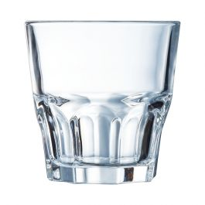

ČAŠA CASABLANCA 2,80 cl 12/1 15,00 eur

ČAŠA CASABLANCA 3,5 cl 12/1 16,00 eur

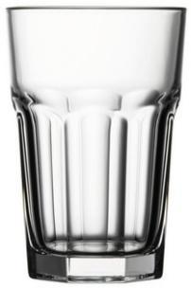

ČAŠA ROYAL VODA 33,50 cl 12/1 21,60 eur

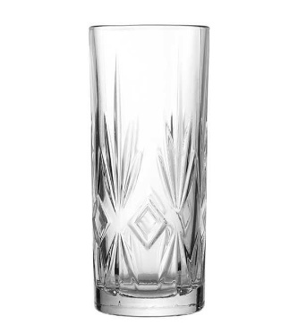

ČAŠA ROYAL WHISKY 30,50 12/1 18,00

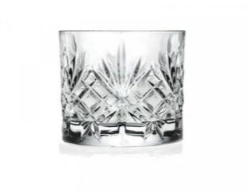

ČAŠA DRAFT 0,2 ŽIG 1,35

0,3 ŽIG 1,48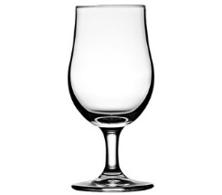

ČAŠA ZA KONJAK PASABAHCE 540 CL 1/1 2,20

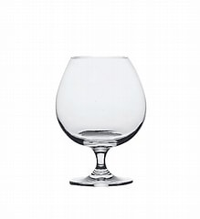

ČAŠA TIMELESS GIN TONIC 5,0cl 4/1 13,05

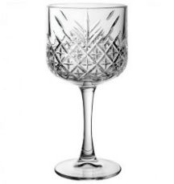

ČAŠA GRAPA RAKIJE 9,5 cl 1/1 1,55

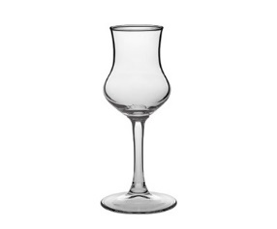



**U ponudi imamo kompletan ugostiteljski program, cijene i modeli na upit.**

**Caffe aparati, mlinci, depuratori ( ručni i automatski ), ledomati, perilice.**